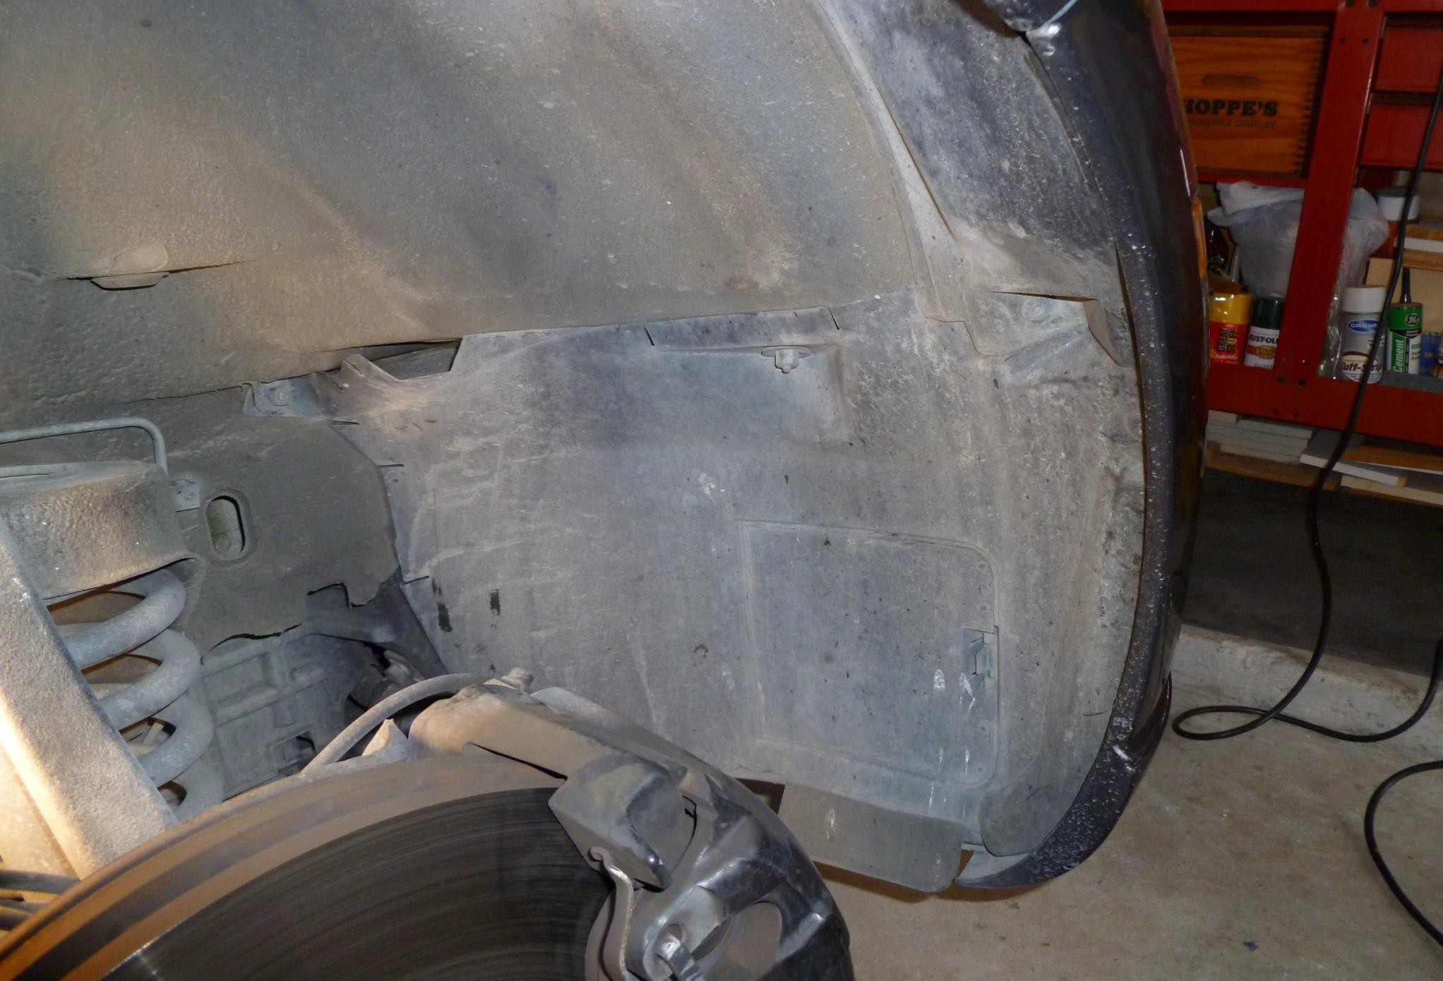

10 MM Nuts
T25 Torx Screws

Phillips Sheet Metal Screw underneath

- Jack up car and remove Passenger side tire
- Remove wheel well bottom panel by removing circled nuts and screws.

3. There is another 10mm nut above the intercooler pump on the bottom of the frame rail to remove the fender well. I had to
remove the bottom cover to get to it. It's hidden above the hoses for the pump (Circled in RED).

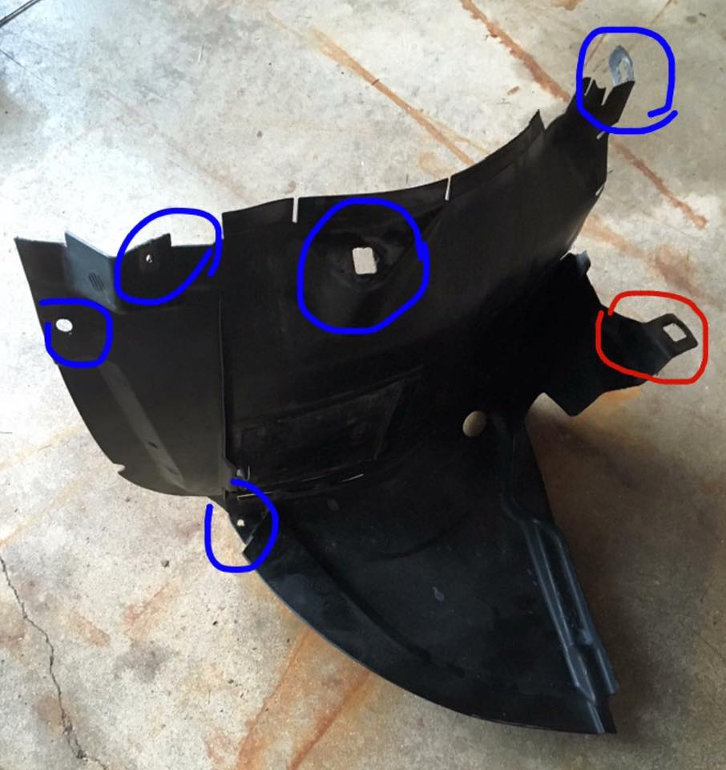

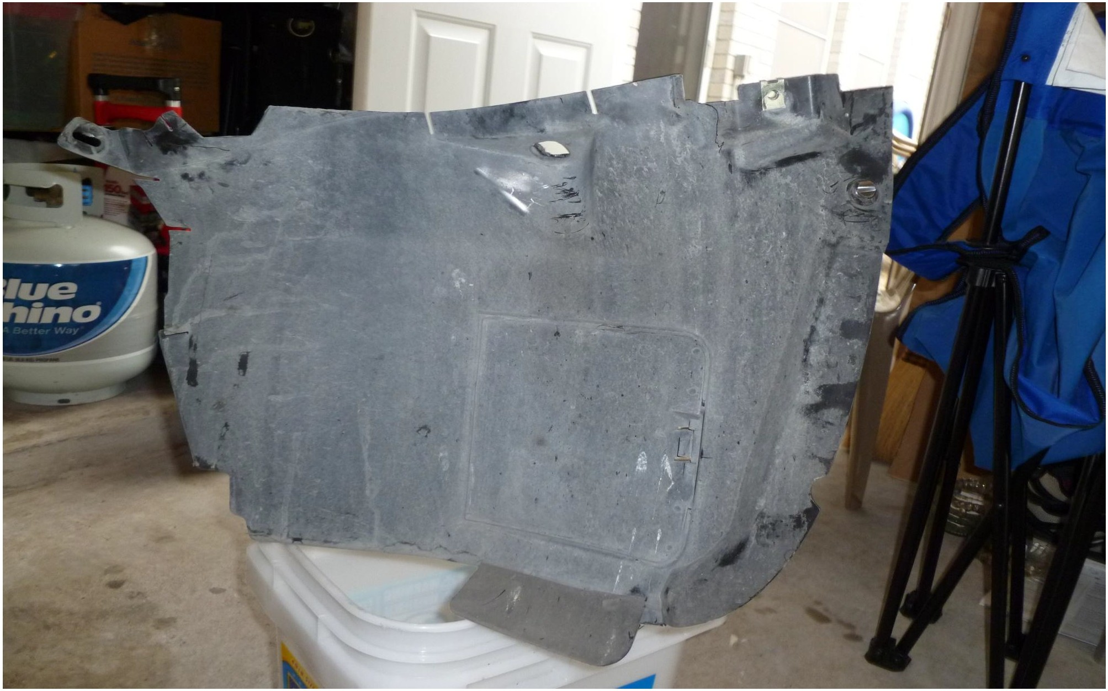

Here’s a picture of the removed panel.
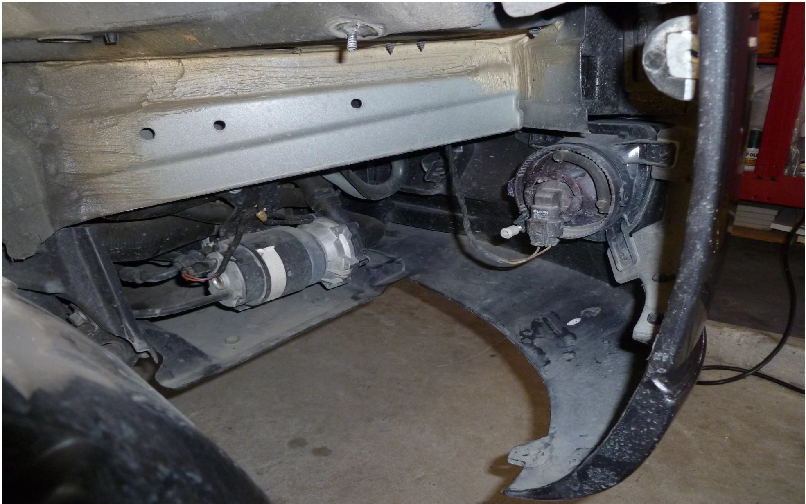

Picture of the IC Pump with the Panel removed.

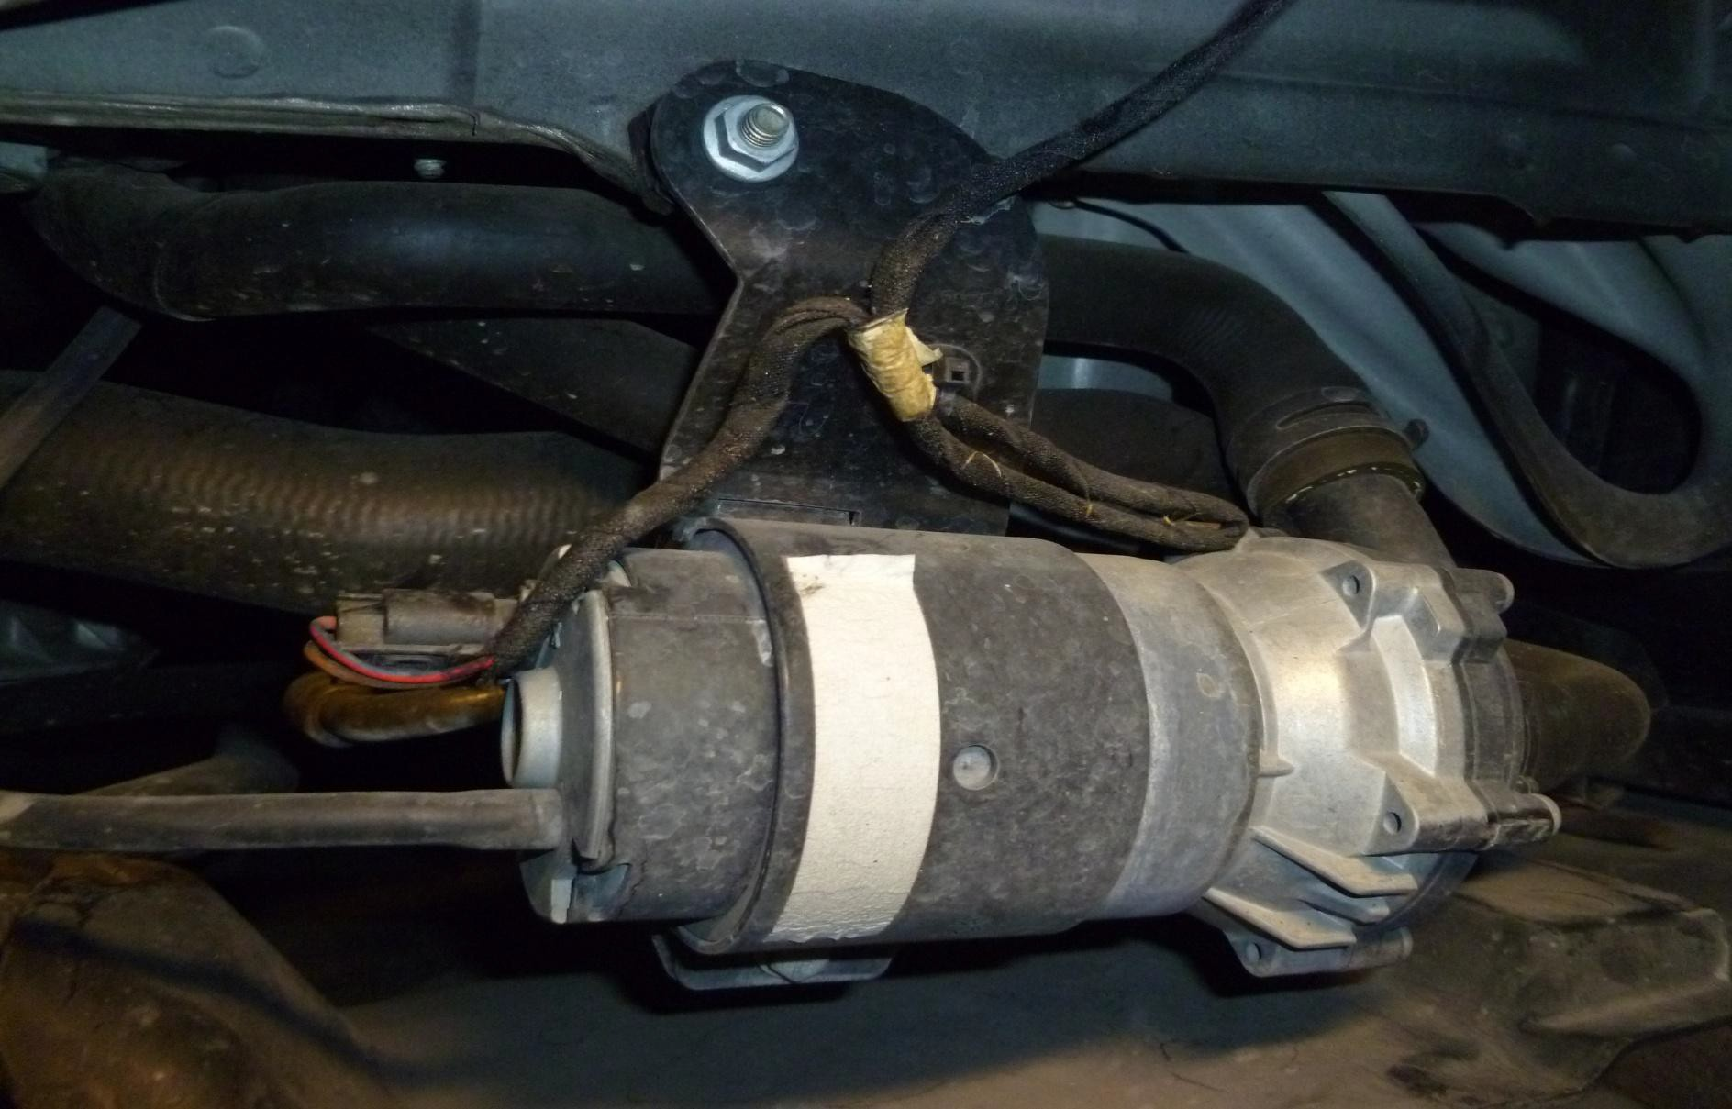
Remove Power Connector

Remove Spring Hose Clamps

Remove 10 MM Bolt

4. Remove Power Connector using a small screw driver to lift the tab on

the bottom of the connector

5. Remove (&*^%#@) Spring hose clamps. I used a set of small channel lock

pliers.

6. Remove Hoses. Make sure you have something to catch the Antifreeze.

You may want to pinch off or plug up the hose ends to minimize

spillage of coolant.

7. Remove 10MM Bolt and you will be able to lift the pump out.

8. Just reverse the removal instructions to install the new Bosch #10

pump (Bosch #0392022010, also M/B #0005000386). Simple Plug & Play if

connector is the same. Replace any spilled Coolant by topping off the

Overflow Tank with Distilled Water up to the high mark tab located

inside the tank. You shouldn’t lose enough coolant to need more

coolant since the 50/50 mix will benefit from the use of more water

perfectly fine.

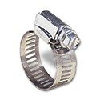
If the spring clamps are too much trouble to reinstall, just use same size hose worm-drive/gear hose clamps.

Most OEM pumps were #03 which use the same pin type connector as the #10. If your pump is an #02, then it’s an aftermarket Ford Cobra pump and uses the spade type connector. If the connector is a spade type, you’ll need to procure a single 2-pin type for the #10 pump. Pin connector body looks like this…

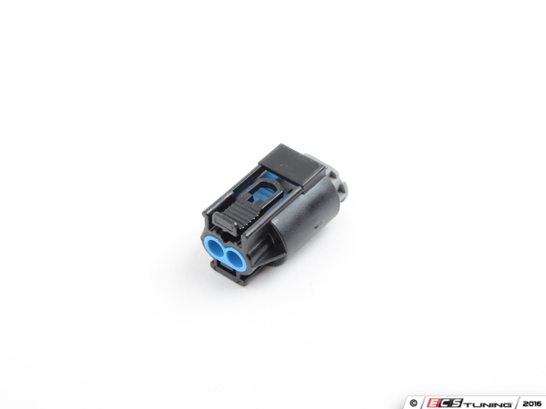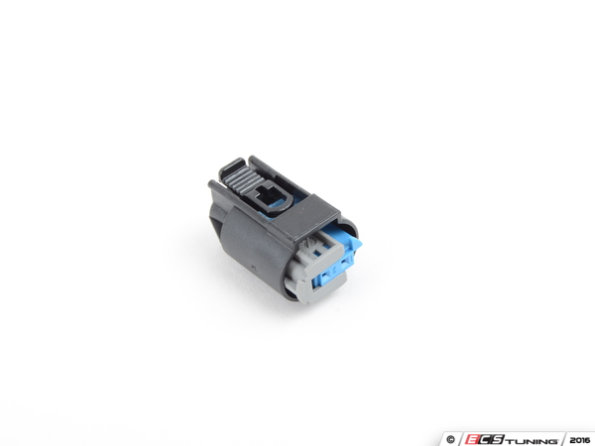

And can be found HERE…
COUPLING

-OR- Also HERE…
PIN BUSHING HOUSING

You’ll also need 2EA Pin Harness Wires to complete the harness…

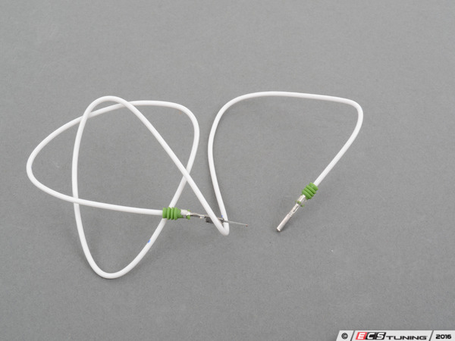
They can be procured HERE…
PIN HARNESS CABLE
Insert the pin end into the rear of the connector and splice the other end onto the OEM cable that has the spade connector cut off, and you’re good to go.

