Crossfires Across America #8 T-SHIRT ORDER FORM
CAA#8 will be held in Eureka Springs, AR from June 25 – June 30, 2017
I have been working with a local Eureka Springs Company Twice Born Designs for the CAA#8 T-shirts and I am ready to start taking orders. We are still working on the designs for the caps and hope to have these available for sale soon. Please note the DEADLINE for orders will be 5/31 to allow the company to complete our orders. Since this is a local company, they have agreed to deliver the T-shirts to the hotel so we can avoid paying any shipping costs. We will have both Crew T-shirts (men and women) or V-neck T-shirts (women only) available. Below you will find a large image to show you what the front logo and back designs look like. Beginning on the second page you will see smaller versions of the Crew T-shirts and the available colors, as well as, two proofs for the Women’s V-neck T-shirts. Though I don’t have a proof for all available V-neck colors, they will be similar to the Crew. Most of the proofs below show the roadster logo, however, please note the coupe logo will also be available for the front logo. The price quoted for each T-shirts (Crew/V-neck) will be the same regardless of size and color. The color choices will be (White, Black, Grey, Yellow, Red, Blue).
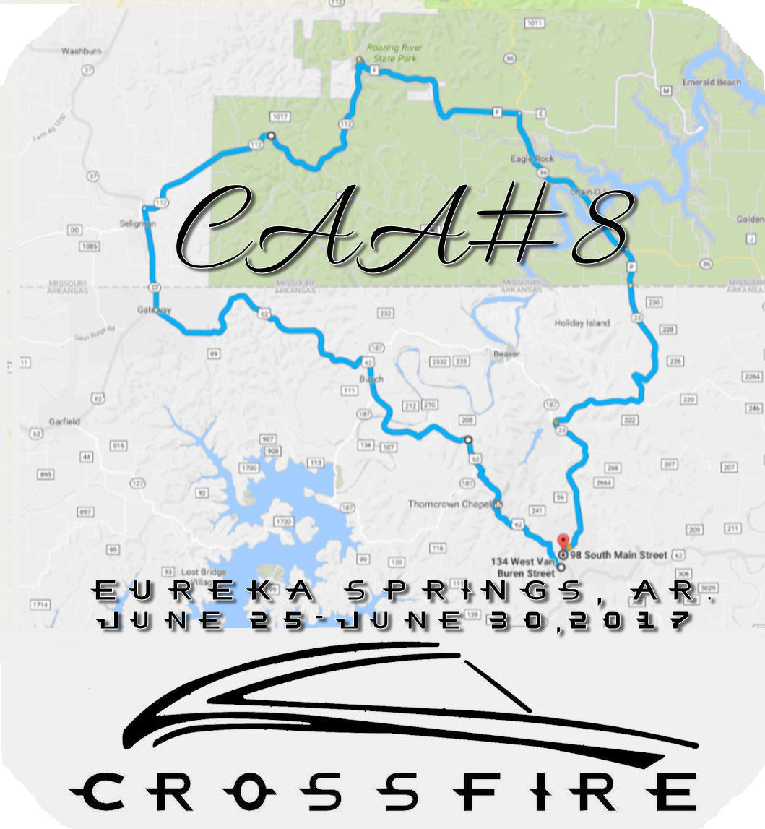
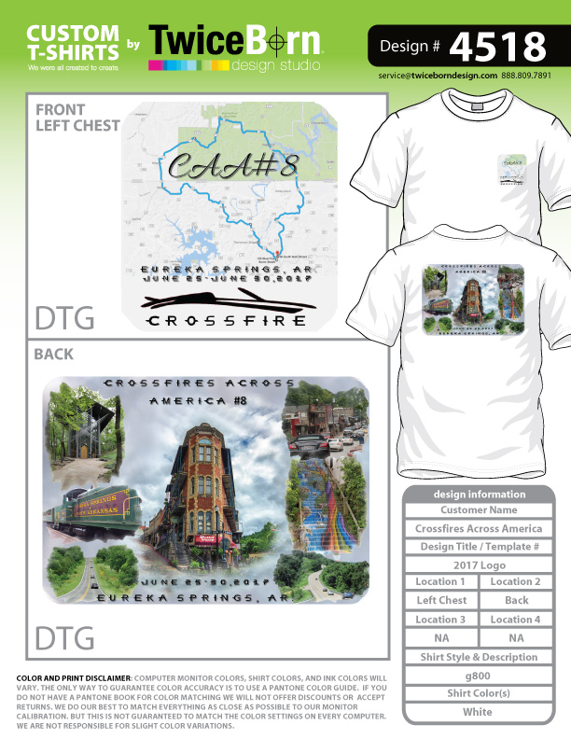

The Crew T-shirts will be Gildan- 50% cotton/50% polyester blend (see below examples). $14.50 each
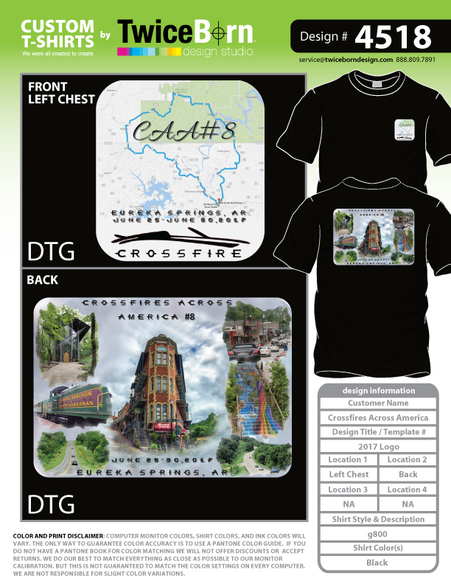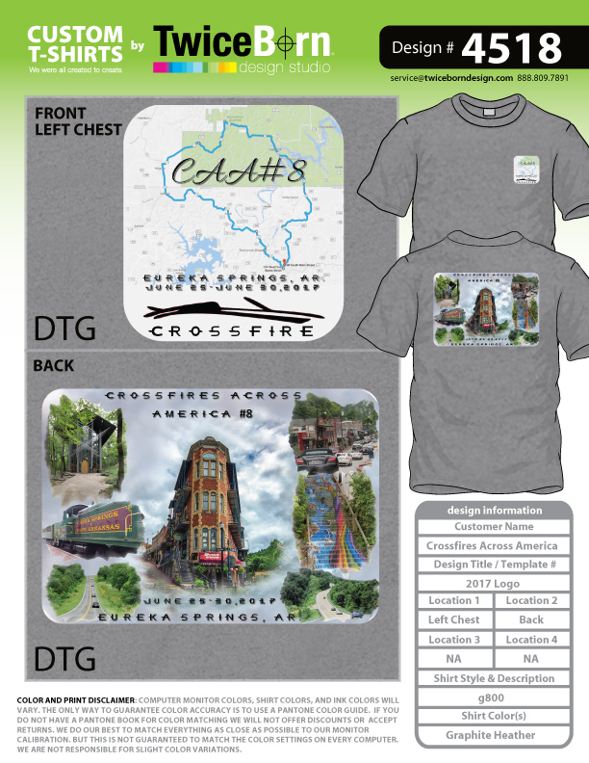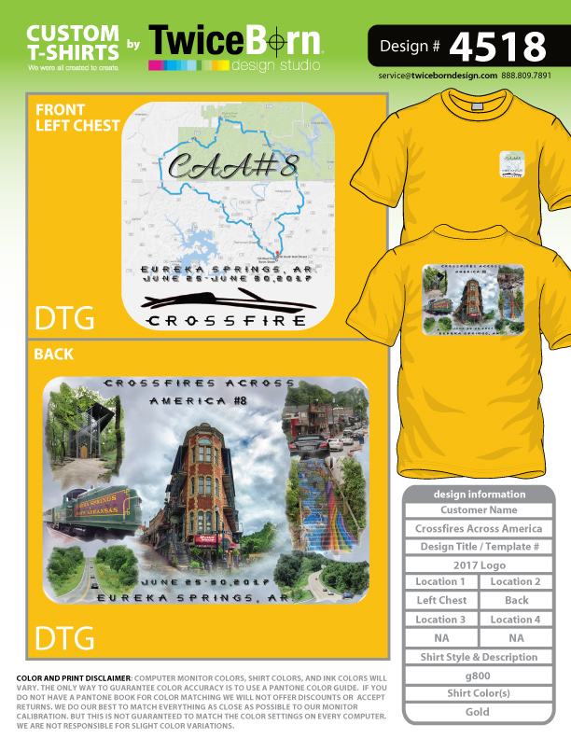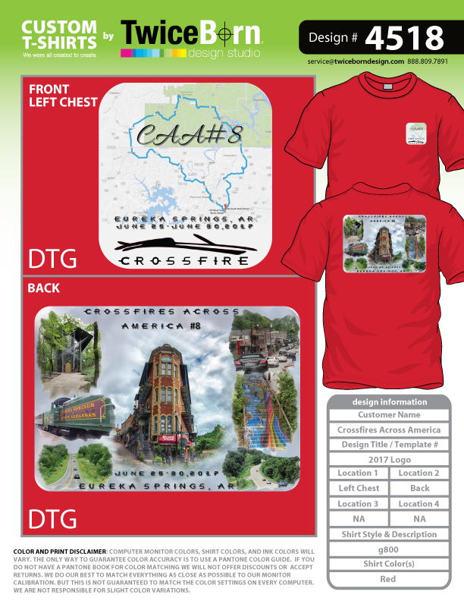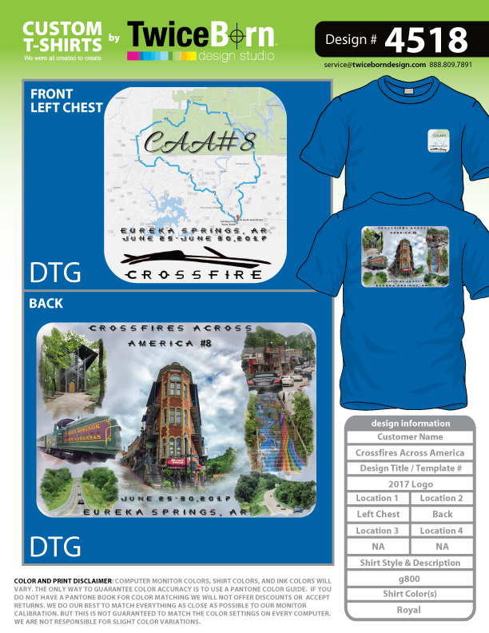
The Women’s V-neck will be 60% combed ringspun cotton/40% polyester lightweight jersey. The V-neck will run smaller. $17.50 each
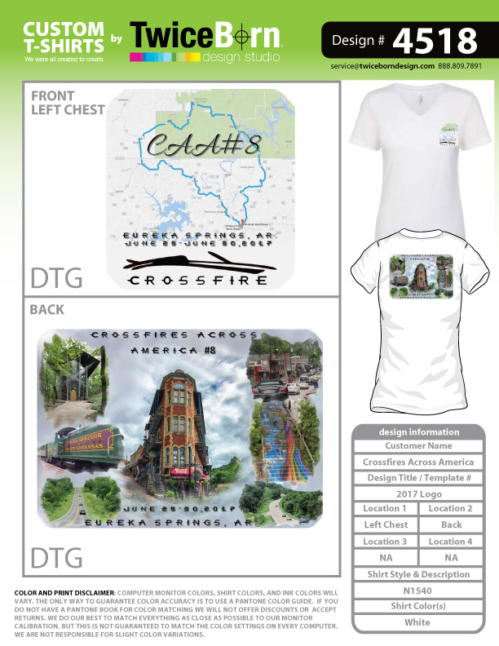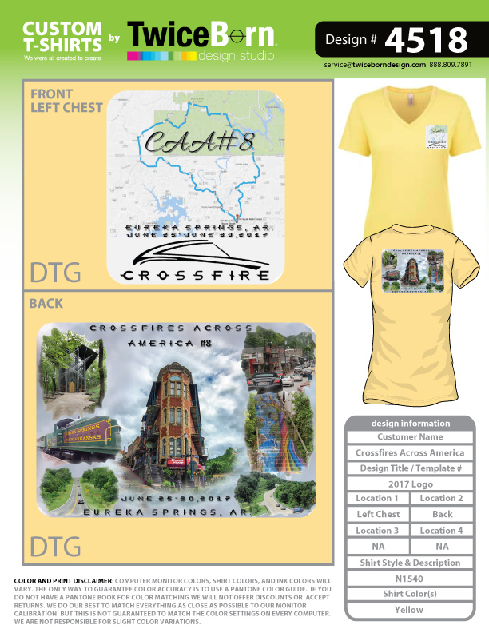

Crossfires Across America #8 T-SHIRT ORDER FORM
Eureka Springs, AR from June 25 – June 30, 2017
Name and Contact Details
Name:
Address:
City, State & Zip:
Mobile / Phone:
Email:
T-Shirt Order (will be delivered to the host hotel and distributed at the event to save shipping costs)

Crew Neck T-Shirt - $14.50 each – Gildan - 50% cotton/50% polyester
Crew Product Specifications
 | S | M | L | XL | 2XL | 3XL | 4XL
BODY LENGTH | 28 | 29 | 30 | 31 | 32 | 33 | 34
BODY WIDTH | 18 | 20 | 22 | 24 | 26 | 28 | 30

Roadster: ____ Coupe: ____

Color (mark with ‘X’):
White | Black | Blue | Red | Grey | Yellow

Qty/Size:
Small | Med | Large | XL | 2XL | 3XL | 4XL | Total $

Women’s V-Neck T-Shirt - $17.50 each - 60% combed ringspun cotton/40% polyester lightweight jersey
Women's V-neck Product Specifications
 | S | M | L | XL | 2XL
BODY LENGTH | 25.5 | 26 | 26.5 | 27 | 27.5
BODY WIDTH | 30.5 | 32 | 34 | 36 | 39

Roadster: ____ Coupe: ____

Color (mark with ‘X’):
White | Black | Royal Blue | Red | Dark Grey | Yellow

Qty/Size:
Small | Med | Large | XL | 2XL | Total $

Total Order $

Payment can be sent via Paypal to anet0911@gmail.com or mail Check or Money Order.

PayPal Check or Money Order

PayPal Email if different from above: Send Payment & Form to: Annette Kirscher
17938 Fountain Circle
Orland Park, IL 60467
Make check payable to: Annette Kirscher
Email Order Form to anet0911@gmail.com
and send payment to PayPal account: anet0911@gmail.com

