Texas Motor Speedway
Laps for Charity II
Itinerary for Saturday, September 26th

• 8-noon - Cars and Coffee
Classic BMW (northwest corner of the parking lot)
6800 Dallas Parkway
Plano, TX 75024
Northwest corner of North Dallas Pkwy & W Spring Creek Pkwy

• 1:00-2:15 - Tour of Texas Motor Speedway's Facility
http://www.texasmotorspeedway.com/VisitorGuide/Driving-Directions.aspx
3545 Lone Star Circle
Ft. Worth, Texas 76177

• 2:30 - Meet at Motel 6 to go to Babes
13601 Raceway Drive
Northlake, TX 76262
Just South of Hwy 114 – East side of 35E

• 3:00 - Lunch at Babes Chicken Dinner House
http://www.babeschicken.com/Babes-Chicken-Dinner-House-Roanoke.html
104 North Oak
Roanoke, Texas 76262
(817) 491-2900

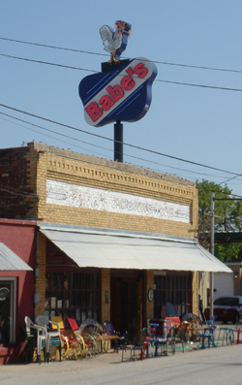

• 5:30 - Meet at Texas Motor Speedway
http://www.texasmotorspeedway.com/VisitorGuide/Driving-Directions.aspx
3545 Lone Star Circle
Ft. Worth, Texas 76177

• 6:00 - Track time at TMS
If you are not there by 5:30, you won’t be part of the group.

